Name: Mushtaque Ali Khaskheli

Assignment: PF Lab 11

Sec: H

Task 1.
Input
#include <iostream>
using namespace std;
struct student
{
int ID[5];
string name[5], department[5], email[5], number[5];
};
int main ()
{
student details;
cout<<"You have to enter record of 5 students.\n\n";

for(int i=0; i<5; i++)
{
cout<<"Enter ID of Student "<<i+1<<" : ";
cin>>details.ID[i];

cin.ignore();
cout<<"Enter Name of Student "<<i+1<<" : ";
getline(cin,details.name[i]);
cout<<"Enter Department of Student "<<i+1<<" : ";
getline(cin,details.department[i]);
cout<<"Enter Email of Student "<<i+1<<" : ";
cin>>details.email[i];
cout<<"Enter Phone number of Student "<<i+1<<" : ";
cin>>details.number[i];
cout<<endl;
}

cout<<endl;
for(int i=0; i<5; i++)
{
cout<<"\nStudent "<<i+1<<" details ";
cout<<"\nID: "<<details.ID[i];
cout<<"\nName: "<<details.name[i];
cout<<"\nDepartment: "<<details.department[i];
cout<<"\nEmail: "<<details.email[i];
cout<<"\nPhone number: "<<details.number[i];
cout<<endl;
}

return 0;
}

OUTPUT
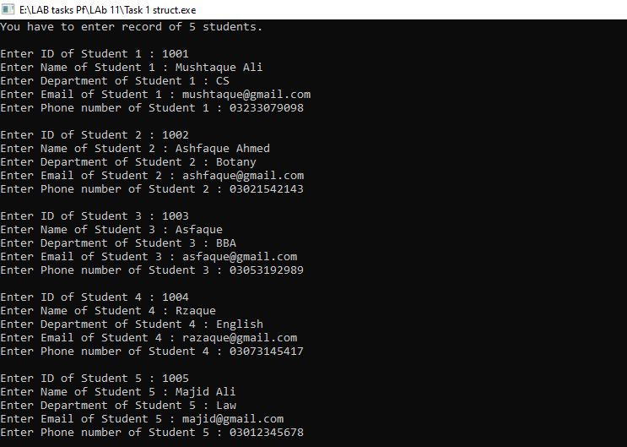
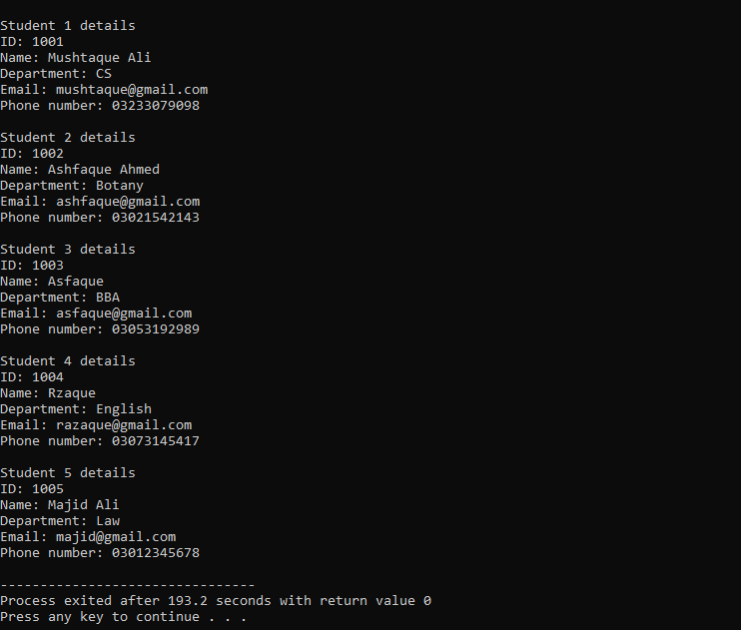

TASK 2.
Input
#include <iostream>
#include <string>
using namespace std;

struct Product
{
int model_num;
int price;
string name;
};

void Products(Product details[10])
{
for (int i=0; i<10; i++)
{
cout<<"\nProduct "<<i+1<<" : "<<details[i].name;
cout<<"\nModel number : "<<details[i].model_num;
cout<<"\nPrice : " <<details[i].price;
cout<<endl;
}
}

int main()
{
Product details[10];
cout<<"You have to enter records of 10 products.\n\n";
for (int i=0; i<10; i++)
{

cout<<"Enter name of product "<<i+1<<" : ";
cin.ignore();
getline(cin,details[i].name);
cout<<"Enter model number of "<<details[i].name <<" : ";
cin>>details[i].model_num;
cout<<"Enter Price of " <<details[i].name<<" : ";
cin>>details[i].price;
cout<<endl;
}

cout<<endl;
Products(details);

return 0;
}

OUTPUT
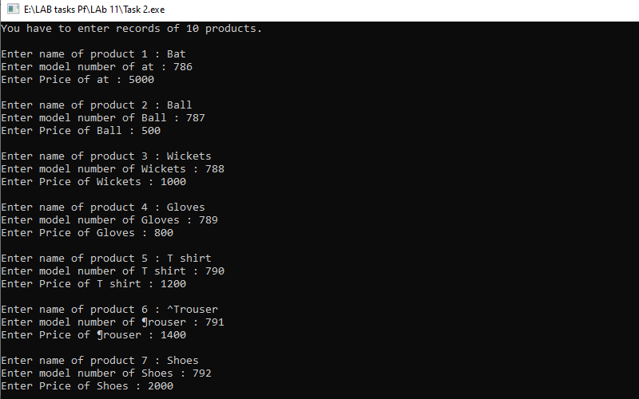
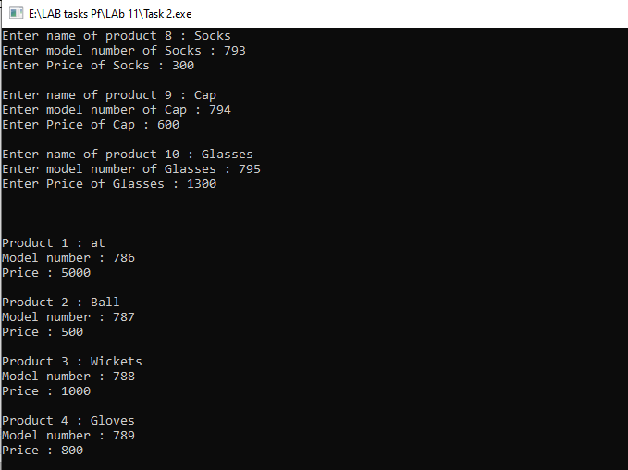
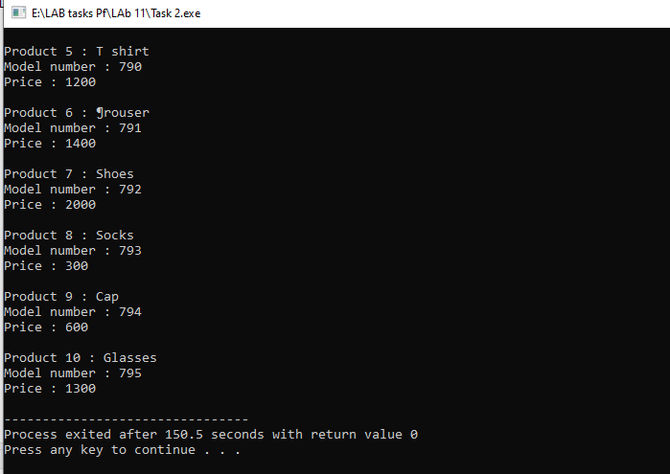
TASK 3.
INPUT
#include <iostream>
#include <string>
using namespace std;

struct Employee
{
int EmployeeNumber;
double BasicSalary, HouseAllowance, MedicalAllowance, Tax, GrossPay, NetSalary;
string Name;
};

void EmpSalary(Employee &data)
{
data.HouseAllowance = 10 * data.BasicSalary/100;
data.MedicalAllowance = 5 * data.BasicSalary/100;
data.Tax = 4 * data.BasicSalary/100;
data.GrossPay= data.BasicSalary+data.HouseAllowance+data.MedicalAllowance;
data.NetSalary = data.GrossPay - data.Tax;
}

void display(Employee &data)
{
cout << "***************************************************************" << endl;
cout << "\t\tEmployee Details:" << endl;
cout << "***************************************************************" << endl;
cout << "Name: " << data.Name << endl;
cout << "Employee Number: " << data.EmployeeNumber << endl;
cout << "Basic Salary: " << data.BasicSalary << endl;
cout << "House Allowance: " << data.HouseAllowance << endl;
cout << "Medical Allowance: " << data.MedicalAllowance << endl;
cout << "Tax: " << data.Tax << endl;
cout << "Gross Pay: " << data.GrossPay << endl;
cout << "Net Salary: " << data.NetSalary << endl;
}

int main()
{
Employee data;

cout<<"Enter Employee number : ";
cin>>data.EmployeeNumber;
cin.ignore();
cout<<"Enter name of Employee : ";
getline(cin,data.Name);
cout<<"Enter Basic Salary : ";
cin>>data.BasicSalary;
cout<<endl;

EmpSalary(data);
display(data);

return 0;
}

OUTPUT
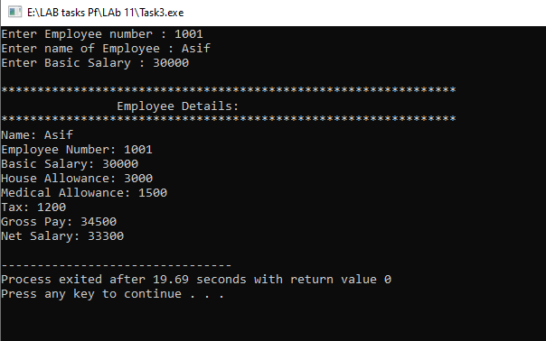

TASK 4.
INPUT
#include <iostream>
#include <string>
using namespace std;

struct Student {
string name;
int id;
int mark[3];
};

void inputStudent(Student* ptr)
{
cout<<"Enter student name: ";
cin.ignore();
getline(cin, ptr->name);

cout<<"Enter student ID: ";
cin>>ptr->id;

cout<<"Enter marks for three subjects:" << endl;
for (int i=0;i<3; i++)
{
cout<<"Mark for subject "<<i+1<<": ";
cin>>ptr->mark[i];
}
}

void displayStudent( Student* ptr)
{
cout<<"Student Details:"<<endl;
cout<<"Name: " << ptr->name<<endl;
cout<<"ID: " << ptr->id<<endl;
cout<<"Marks for three subjects: ";
for (int i=0; i<3; i++)
{
cout<<ptr->mark[i]<<" ";
}
cout<<endl;
}

int main()
{
Student stu;
Student* stuPtr = &stu;

inputStudent(stuPtr);
displayStudent(stuPtr);

return 0;
}

OUTPUT
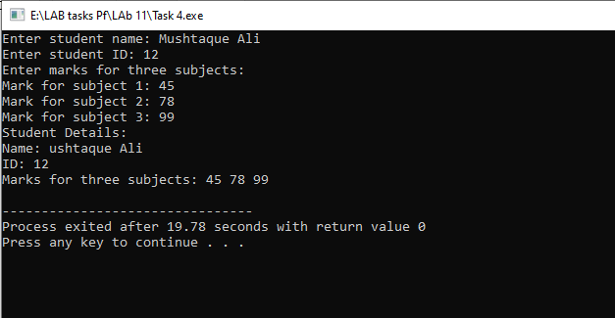

TASK 5.
INPUT
#include <iostream>
#include <string>
using namespace std;
struct student
{
int id;
string name;
int*marks;
};

void inputStudent(student*ptr, int marks)
{
cout<<"Enter ID of Student : ";
cin>>ptr->id;

cin.ignore();
cout << "Enter student name: ";
getline(cin,ptr->name);

ptr->marks= new int[marks];
cout<<"Enter marks of "<<marks<<" subjects : \n";

for(int i=0; i<marks; i++)
{
cout<<"Marks for subject "<<i+1<<" : ";
cin>>ptr->marks[i];
}
cout<<endl;

}

void display(student*ptr, int marks)
{
cout<<"Student ID : "<<ptr->id;
cout<<"\nStudent name : "<<ptr->name;
cout<<"\nMarks of "<<marks<<" subjects : \n";

for(int i=0; i<marks; i++)
{
cout<<"\nMarks for subject "<<i+1<<" : "<<ptr->marks[i];
}
cout<<endl;

}

void deletememory(student*ptr)
{
delete[] ptr->marks;
}

int main ()
{
int marks;
cout<<"Enter number of subject marks : ";
cin>>marks;

student stu;
student*ptr=&stu;

inputStudent(ptr, marks);
display(ptr,marks);
deletememory(ptr);

return 0;
}

OUTPUT
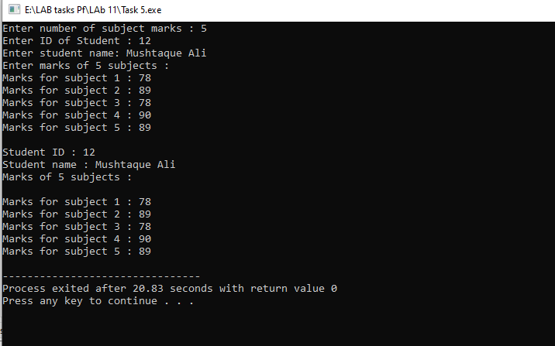

The End

